Primary 5 Homework
Term 3

Children should complete at least 4 tasks (or more) from the grid. Tasks with * must be completed.

When you have completed an activity, tick it off and date it.
This grid is due back into school by Monday 30th March 2020.

*Be a Multiplication Star  Log on to SumDog and do the Multiplication Tables Challenge to practise your times tables.  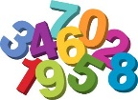  When you log on you should see it as a challenge. If not, hit the green “choose activity” button and then select “Multiplication Tables Challenge”. | 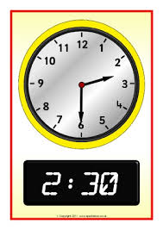  Be numerate  We are doing time in maths. Have a look around your home and take a note of different places where you have clocks. Are they digital or analogue clocks (clocks with hands)? What time do they say? Which times are important for you? Write them down.
Be an author  Write a story set in the past, in the time of Mary Queen of Scots. Imagine you are a child there. How could you meet the queen? Maybe you bring food to her? Maybe you help her to escape from Loch Leven castle? What would she say to you? Would she give you a little gift to thank you? 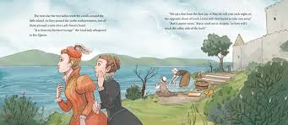 | *Be a hard worker  One of our school values is to ‘work hard’. We will be completing a whole school display with examples of a time when we have worked hard.  Can you write about a time when you have worked hard? Did working hard make a difference to the outcome?  This can be an in or out of school example of working hard.
*Be resilient  Decorate the body shape by illustrating all of the skills, talents and abilities you have.  Next, add words around the outline to show things that you would like to learn in the future.  Finally, ask your parent/carer to write a positive and encouraging statement about you at the bottom of the sheet. | Be a reader  Begin the First Minister’s Reading Challenge (FMRC).  Record any texts that you have read in your FMRC booklet.  Remember a text can take many forms. It is something you can read, watch or listen to : a book, comics, novels, short stories, magazines, websites, graphic novels, poems, YouTube etc.

I am working within the _____________ spelling belt in Rosewell Tricky words.

I am working within the _____________ colour on Maths Basic Facts.

