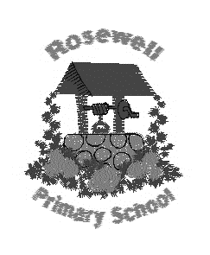
Primary 7 Homework
Term 3

Children should complete at least 5 tasks (or more) from the grid. Tasks with * must be completed.

When you have completed an activity, tick it off and date it.
This grid is due back into school by Monday 30th March 2020.

*Be a Multiplication Star  How far can you get in the multiplication challenge?  You must pass each medal level before you can move onto the next one.  Practise at home and let Miss Wilson know when you are ready try a medal. | Be an artist  Practise your sketching skills by sketching a WWII weapon, for example a WWII aircraft.  Remember to title your piece of art so that people know what it is.  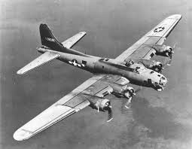
Be descriptive  We have been using figurative language in our writing.  Create ten sentences about the war – each sentence must have an example of figurative language.  Remember you can use: similes, onomatopoeias, metaphors, alliteration and WOW vocab to create a descriptive image. | *Be a hard worker  One of our school values is to ‘work hard’. We will be completing a whole school display with examples of a time when we have worked hard.  Can you write about a time when you have worked hard? Did working hard make a difference to the outcome?  This can be an in or out of school example of working hard.
*Be resilient  Decorate the body shape by illustrating all of the skills, talents and abilities you have.  Next, add words around the outline to show things that you would like to learn in the future.  Finally, ask your parent/carer to write a positive and encouraging statement about you at the bottom of the sheet. | Be a reader  Begin the First Minister’s Reading Challenge (FMRC).  Record any texts that you have read in your FMRC booklet.  Remember a text can take many forms. It is something you can read, watch or listen to : a book, comics, novels, short stories, magazines, websites, graphic novels, poems, You Tube etc

I am working within the _____________ spelling belt in Rosewell Tricky words.

I am working within the _____________ colour on Maths Basic Facts.

