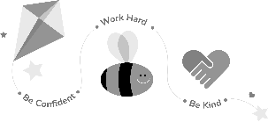
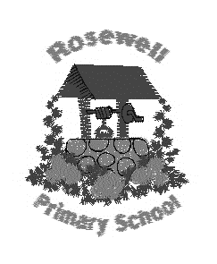
Primary 4/3 Homework
Term 3

Tasks with * must be completed. There are four of these . Children should then complete at least 1 other task from the grid. When you have completed an activity, tick it off and date it.

This grid is due back into school by Monday 30th March 2020.

Be Creative  We have been looking at robotics this term. Can you design your own robot? What would its special features/functions be? Would it help clean the house, do your homework, walk the dog? You decide. You can draw or make this. Remember it needs to be detailed and needs a description of what its special features are. | 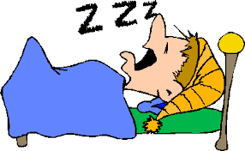  Be a Sound Sleeper  Did you know … your brain grows as you sleep? The more you sleep the healthier you are too. Using an electronic device before bedtime makes it harder to fall asleep. Write a pledge in your jotter to switch off any devices at least two hours before bedtime and stick to it! Make a note of how many nights you manage this.  Why not read a book instead and fill in another page of your FMRC ?
* Be A Mathematician  Take part in the Times Table Challenge. Go for Bronze , Silver or Gold . Get an adult to help you learn your times tables. Start with one that you think you are confident with then go from there.  When you are ready to be tested let Mrs Richardson know and she will check with you. Your times tables challenge sheet will help you . Don’t forget you can use SUMDOG to help you too. | *Be a Hard Worker  One of our school values is to ‘work hard’. We will be completing a whole school display with examples of a time when we have worked hard.  Can you write about a time when you have worked hard? Did working hard make a difference to the outcome?  This can be an in or out of school example of working hard.
*Be Resilient  Activity  1. Think about the talents and skills that are special about you. These talents and  qualities are part of what makes you unique.  2. In your jotter draw an outline of you. Decorate the body shape by illustrating all of the skills, talents and abilities you have.  3. Next, add words around the outline to show things that you would like to learn in the future.  4. Finally, ask your parent/carer to write a positive and encouraging statement about you at the bottom of the page. | Be a Reader  Begin the First Minister’s Reading Challenge (FMRC).  Record any texts that you have read in your FMRC booklet.  Remember a text can take many forms. It is something you can read, watch or listen to : a book, comics, novels, short stories, magazines, websites, graphic novels, poems, You Tube etc

For spelling * – see back of this sheet (this is a ‘have-to’ task)

*Spelling Activities - Weekly
Choose one activity each week to learn your spelling words.
Depending on the task your words should always be written in cursive writing.
Try a different activity each week. Please ask a grown-up to sign when complete.
- Rainbow spelling . Choose a different colour for each letter . How colourful can you be?

- Use two words together in a sentence underline them and you must have a connective. Eg The yellow pencil was hidden below the red pencil as a result of this it couldn’t be found.

Use from the following list of connectives:

Except although next then as a result finally because as well as

- Write your words in alphabetical order

- Bubble writing

- Spelling tennis – ask an adult to help you with this . Sound the word out aloud and ask the adult to say the alternative letter eg y-e-l-l-o-w Pass the word backwards and forwards

- Choose your favourite pen – write beautifully !

I am working within the _____________ spelling belt in Rosewell Tricky words.

I am working within the _____________ colour on Maths Basic Facts.

