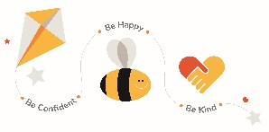
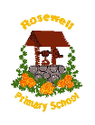
Early Learning Centre Closure Home Learning Grid

How Many?  How many different words can you make from the letters in this sentence:  ‘Learning from home is fun.’ | Building Challenge  Build a famous structure (or a brand new one) using Lego, playing cards or anything else you have at home. | Secret Code  Create your own secret code using pictures, letters or numbers and see if you can get someone to crack it! | Nature Diary  Look out of the window each day and keep a note of what you see – birds, flowers, changes in weather.
Reading Den  Build a reading den at home and curl up with one of your reading books. Read aloud to someone else or read on your own. | Puppets  Use an old sock to create a puppet. | List Making  Make a list of all the electrical items in each room of your home. Can you come up with a way to reduce electricity? | Board Game  Design and make a homemade board game and challenge your family to a game.
Kindness  Do something kind for someone else in your home. Yes, maybe even your brother or sister! | Invention  Can you invent something new? Perhaps a gadget or something to help people. Draw a picture and write a description. | Dance  Create a dance routine to your favourite song. | Play Script  Write a play script and assign different roles to people in your family.
Sketch  Take time to sit and sketch a picture of your choice. Use pencil work or any other materials available to you at home. | Junk Modelling  Make use of the recycled materials at home and create something interesting. It could be a character, an object or even a scene. | My View  Look out one of your windows. Draw the view you can see from your window in detail. | Read Read Read  Read every day!! To yourself, to a family member or listen to an audio book.
Practice Practice Practice  Practice and spelling sounds or words you may have at home.  Practice your times tables as much as you can. Get someone at home to test you! | Review  Write a review of a book, film or song/album. How many stars would you give it? | Personal Project  Choose a topic of your choice and create a project about it. You could make a poster, leaflet, report or a piece of art to represent your work. | Recipes  Follow a recipe and make something tasty! This is great practice of your maths and numeracy skills!

