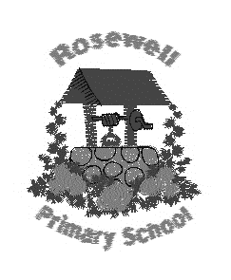
Rosewell Primary School
Accessing Home Learning Guidance

The following is guidance for accessing all of the internet based learning that you have log in details for.

If you have any issues logging in, please contact us on email: rosewell_ps@midlothian.gov.uk

To access Glow

https://glow.rmunify.com/

Type in your username and password then click ‘sign in’.

To access Google Classroom

- Log into Glow as above.
- From the Rosewell Primary School launch pad, click on ‘Google Classroom’
- Click on the + button at the top right of the screen and click ‘join class’
- Enter your Google Classroom code printed on the ‘My Distance Learning Login’ sheet
- Welcome to your Google Classroom!

To access Sumdog

https://www.sumdog.com/

To access Education City

https://www.educationcity.com/

To access IDL (for P3 to P7)

https://idlsgroup.com/

- Click on ‘My IDL Login’
- Enter your username and password
- Select literacy
- Click on the lesson

